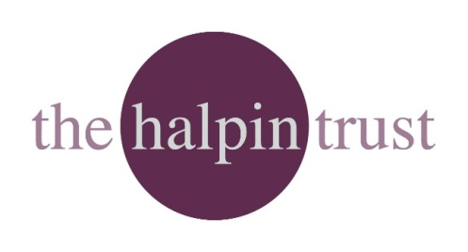
Halpin Trust Development Grant (£15,000 maximum)
It is one of our guiding principles at the Halpin Trust that we want to use our money to promote lasting societal and environmental impact – that is, we want to ensure that the benefits of our investment make a lasting difference in the areas of work that we support rather than needing regular inputs of grants to keep going. We are also keen to apply that approach to the charities we support: to make investments that can enable you to grow or become more financially resilient and sustainable rather than being locked into an endless cycle of grant applications and grant dependency.
To help you we have therefore now launched the Halpin Trust development grant: a fund of up to a maximum of £15,000 to be used by charities to help such areas as business planning, strategic development, fundraising planning, or staff capability building – any area where we can help your charitable business to be more robust and resilient.
Applications could cover such area as:
- payment for external consultants to work with you on the production of business plans, fundraising strategies, better governance structures, or the development of other specialist skills that improve your long-term capability;
- payment for training, mentoring or coaching, especially if it can be demonstrated that the training can benefit the whole organisation rather than just individuals;
- backfilling of staff time to enable you/them to spend time on business planning or strategic work, so that you can continue to deliver your core charitable services, and where you can demonstrate the value to the long-term robustness of your business model;
- other development work that you feel fulfils our criteria.

Your application should be specific about how the money would be spent across the different areas, including number of hours and cost per hour, and an approximate timescale over which the development, consultancy, training, mentoring , backfill would take place. It should be linked to what the benefits would be for your organisation, its work and future development, sustainability and capability.
It is a condition of any grant that a brief report is provided by the receiver within a mutually agreed period – normally 12 months - of the award being made.
A template application form is attached for your convenience. Please submit applications by email to info@halpintrust.org.
There is no fixed deadline for applications, but we will review applications only at our Trustee meetings, which take place 3 times a year.

Charity or organisation details
Name:
Registered charity number:
Website:
Registered address:

Key contact details
Contact name: Position:
Email: Telephone:

Amount requested (with breakdown of ask)

Spend timetable

How will the Halpin Trust investment ensure your financial sustainability and/or capability to deliver your core charitable objectives?

Other relevant information

